Given a digit string, return all possible letter combinations that the number could represent.

A mapping of digit to letters (just like on the telephone buttons) is given below.

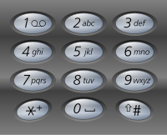

**Input:**Digit string "23"

**Output:** ["ad", "ae", "af", "bd", "be", "bf", "cd", "ce", "cf"].

**Note:**

Although the above answer is in lexicographical order, your answer could be in any order you want.